**Waterfall Model in Software engineering**

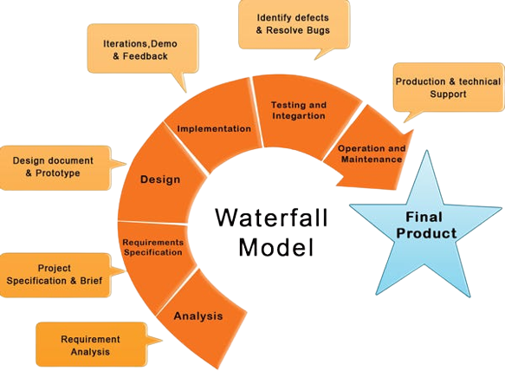

**By:** **Abdullah Niaz**

**Software Engineering**

Traditional waterfall model is a sequential project management method with a linear approach to development where the majority of project deliverables and stakeholder requirements are defined at the start and documented into a rigid development plan.

The six stages of the Model flow chronologically from 1-6 as follows:

* 1. SOFTWARE REQUIREMENTS
  2. ANALYSIS
  3. SYSTEM DESIGN
  4. CODING & IMPLEMENTATION
  5. TESTING & VERIFICATION
  6. OPERATION & MAINTENANCE

# Use OF waterfall model:

* The waterfall model was widely popularized by manufacturing, construction, and engineering industries that highly depend on defining rigid requirements upfront. Waterfall model was also widely adopted in software development before alternative development methodologies such as Agile gained more traction and support.

# Advantages of waterfall model:

1. **The model is easy to follow and explain:** Waterfall model facilitates specific deliverables defined to every phase of the project.
2. **Swift resource allocation:** Waterfall allows for easily allocating huge resources over a long timeframe. End goals are early defined.
3. **Product definition is consistent:** There are no ambiguous requirements throughout the whole project lifecycle.
4. **Easy to manage:** The majority of requirements are defined upfront and development phases are sequential, which makes the waterfall development predictable and easier to manage.

# Disadvantages of Waterfall Model:

1. **Makes changes difficult:** Since Waterfall employs stages, it maintains the belief that each phase must be 100% complete before moving on to the next. This rigidity has an obvious problem; if your project needs unexpected changes or revisions, you must go back to where the requirement has to be altered and start that phase all over again
2. **Excludes the client and/or end user:** Waterfall concentrates very little on the end user of a product. As a methodology, it focuses more on guiding the internal process of development and helping the teams within it.
3. **Delays testing until after completion:** Quality testing does not appear in Waterfall until you are into the second half of the project. Therefore, if you are at an advanced stage when you discover quality problems with the product its flow can be blocked.
4. **No Overlapping:** Processes within this model do not overlap and, as a result, efficiency is undoubtedly reduced.